**Document for Enabling and Disabling EST and EDT Events**

**-------------------------------------------------------------------------------**

**Note:**

**Enable "EDT" ( and disable "EST") schedules when daylight-savings time starts.**

**Enable "EST" (and disable "EDT") schedule when daylight-savings time ends**

**Steps for enabling schedulers Events:**

Step1:

* Login to the AWS console and in the search bar search for EventBridge
* Once you see the Amazon EventBridge service, click on Amazon EventBridge
* Refer the below screen shot.

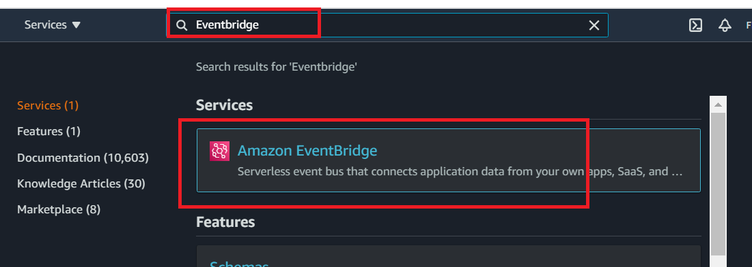

Step2:

* Navigate to the left side of the screen
* Click on the Rules.
* Refer the below screen shot

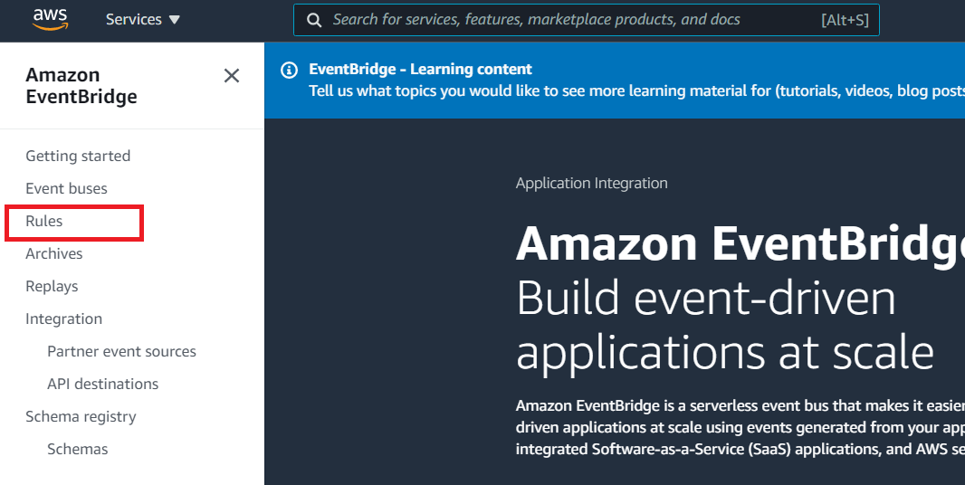

Steps 3:

* In the Rules, search for Event name which you want to Enable.
* For example, if you want to enable EDT time zone Events then search for EDT-NACHA
* Total there will be **2 matches** for EDT-NACHA.
* Refer the below screen shot.

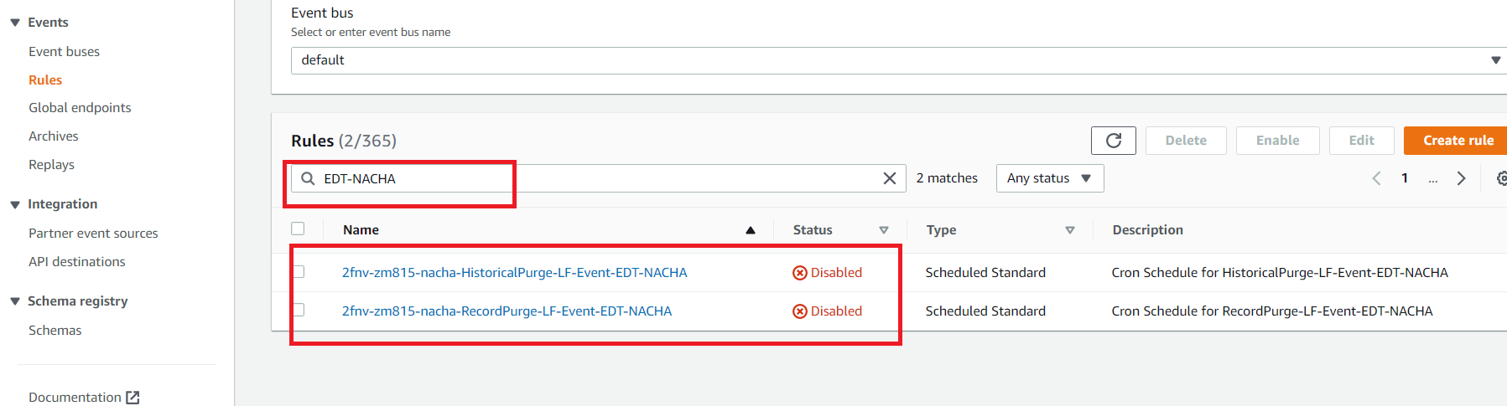

Step 4:

* Select one of the Event by clicking on the Radio button against Event Name which you want to Enable
* Then click on the Enable tab
* Refer the below screen shot

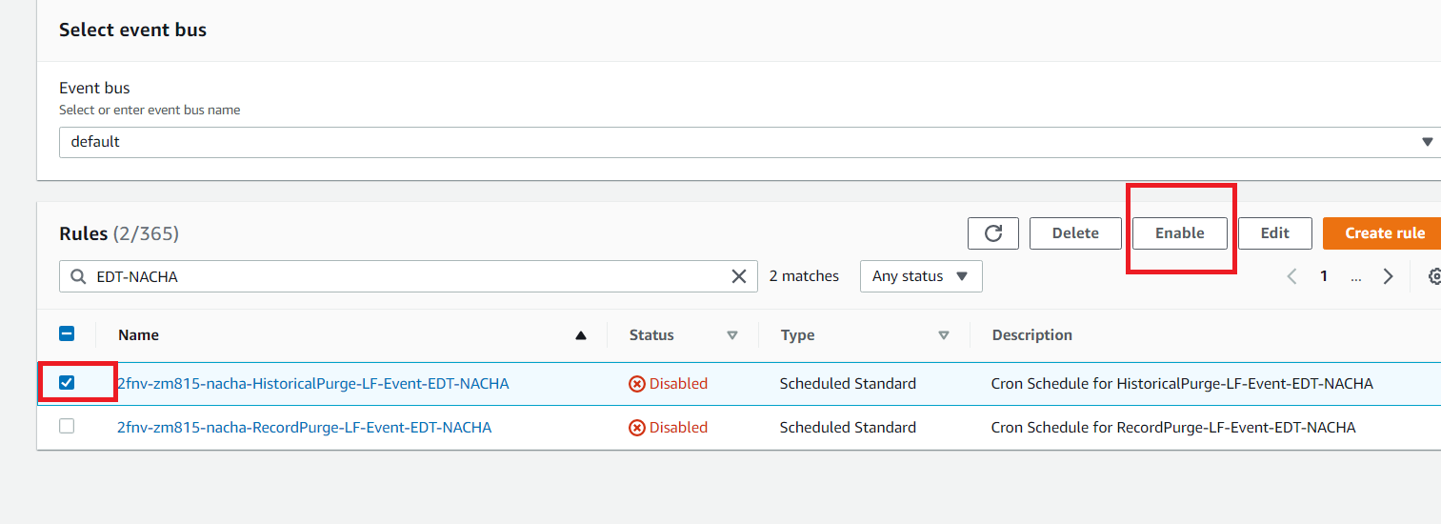

Step 5:

* Once you click Enable Tab, It will render to the below page for Conformation .
* Then click on Enable tab.
* Refer the below screen shot.

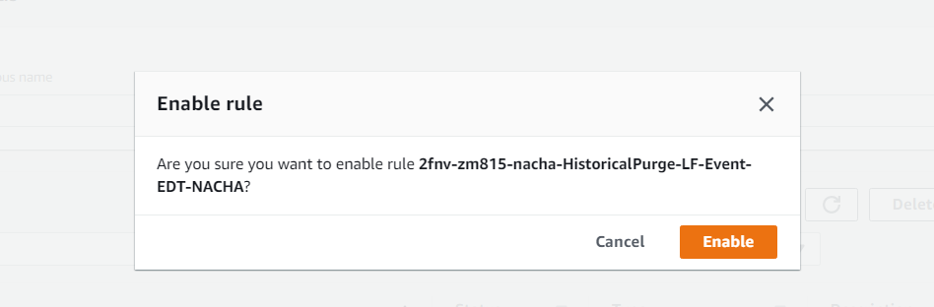

Step: 6

* The Event status will be changed to Enable
* Follow the step 4 and step 5 for all the 2 Events.
* Recheck and make sure that all the Events are Enabled

**Steps for Disabling schedulers Events:**

Step:7

* In the Rules, search for Event name which you want to Disable.
* For example, if you want to disable EST time zone Events then search for EST-NACHA.
* Total there will be **2 matches** for EST-NACHA.
* Refer the below screen shot.

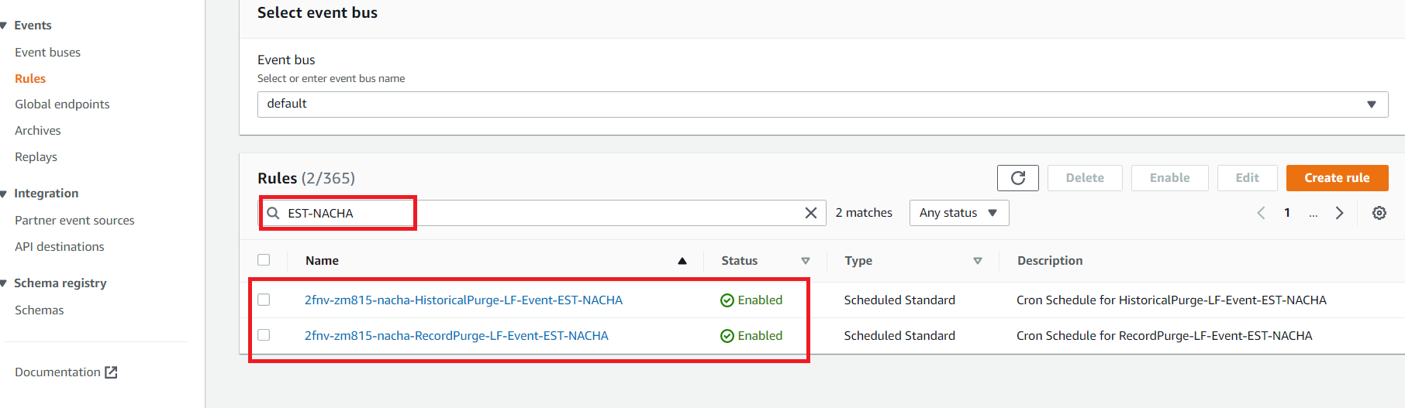

Step 8:

* Select one of the Event by clicking on the Radio button against Event Name which you want to Disable
* Then click on the Disable tab
* Refer the below screen shot

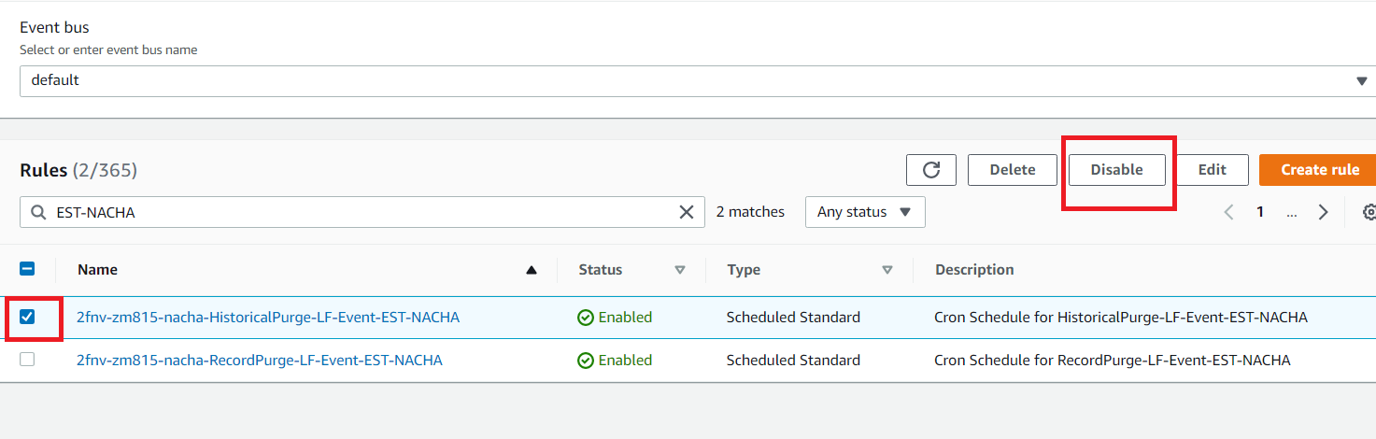

Step 9:

* Once you click Disable Tab, It will render to the below page for Conformation .
* Then click on Disable tab.
* Refer the below screen shot.

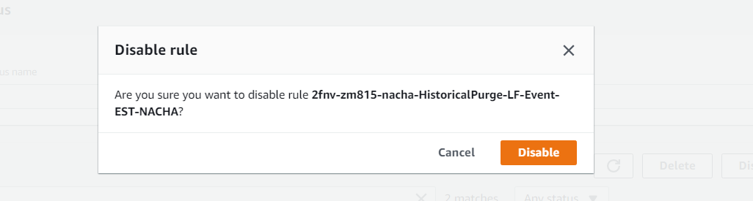

Step 10:

* The Event status will be changed to Disabled state
* Follow the step 8 and step 9 for all the 2 Events.
* Recheck and make sure that all the 2 Events are Disabled